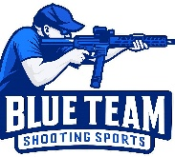
Blue Team Shooting Sports A.S.S.S. April 28th. 2026
COURSE DESIGNER: Ike Starnes

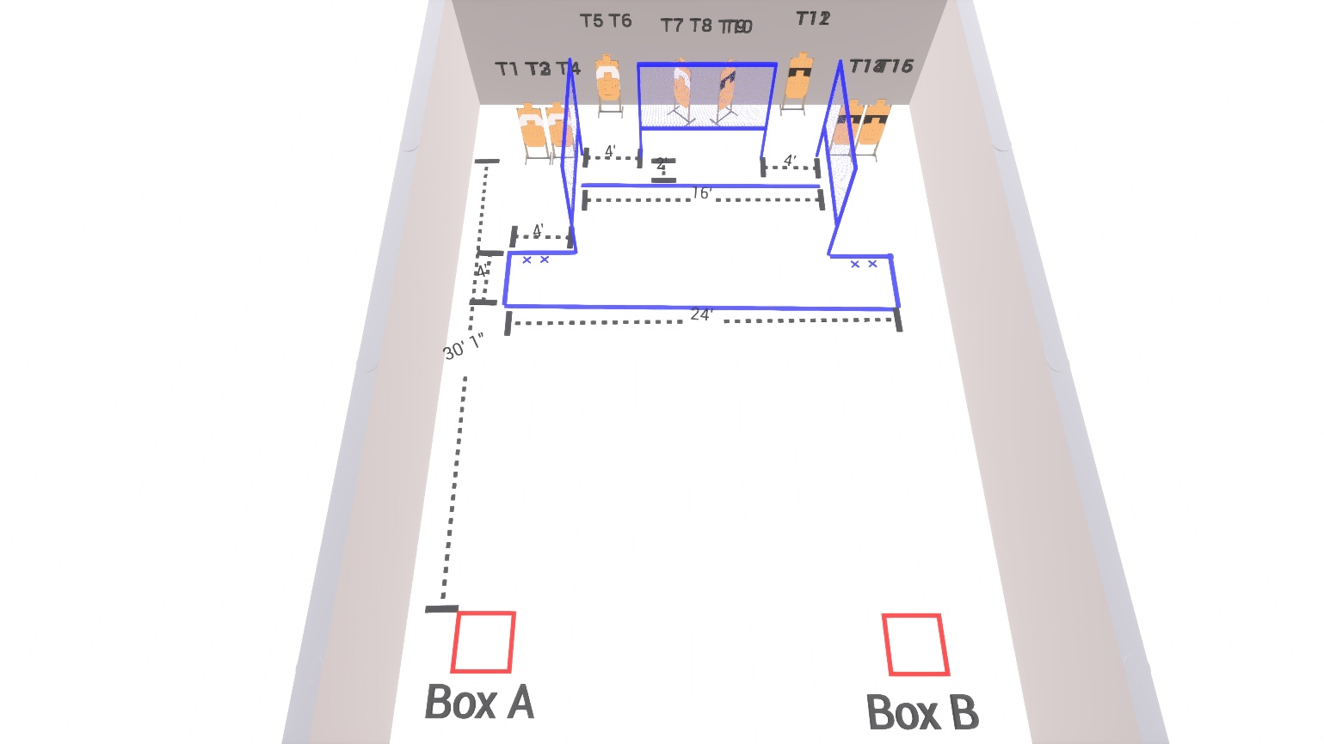

Written Stage Briefings:

Stage 1 – I ain't happy, I'm feeling glad - is an 8-round, 40 point, Virgina Count Course. There are 4 cardboard targets. The best 2 hits per cardboard target will be scored.
Handgun start position Inside Box A. The handgun is unloaded and holstered.
PCC start position Inside Box A. PCC is unloaded, held in both hands, with stock touching belt.
On the audible start signal, engage T1 – T4 with only 2 rounds each.

Stage 2 – I got sunshine in a bag - is an 8-round, 40 point, Virgina Count Course. There are 4 cardboard targets. The best 2 hits per cardboard target will be scored.
Handgun start position Inside Box B. The handgun is loaded and holstered.
PCC start position Inside Box B. PCC is loaded, held in both hands, with stock touching belt.
On the audible start signal, engage either T13 – T14 or T15 – T16 with only 2 rounds each, then make a mandatory reload and engage the remaining targets with only 2 rounds each.

